Design Document

Game Name:

* Tappu Sushi

Genre:

* Casual Mobile Game
* Twitch Game

Target Audience:

The game is aimed at 8 – 30 year olds, both males and females.

Logline:

The players collect the most sushi in the available time by timing their taps to get the highest score.

Theme:

The central setting will be a Japanese sushi bar with the foods being anthropomorphised and true to the central setting.

For example:

* Prawn tempuras smiling with big eyes.
* Dumplings smiling with rosy cheeks.

Menu Flow:

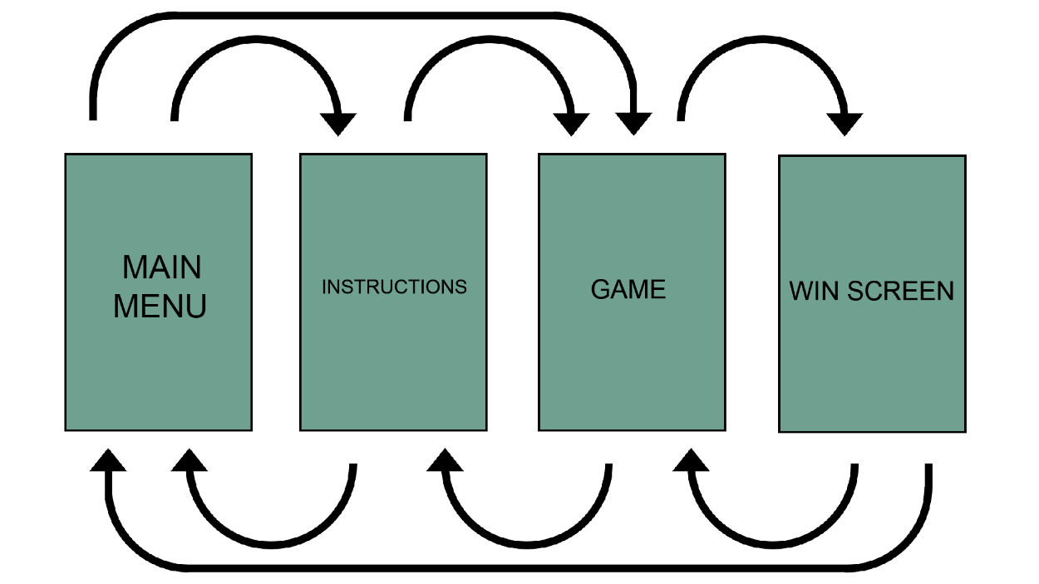

UI:

Menu:

* Play button
* Instructions button

Instructions screen:

* Play button
* Back button

Game:

* Pause button
* Score
* Send food button
* Hit accuracy
* Tap food button
* Timer

Win screen:

* Play again button
* Main menu button

Project Scope:

Initial Pitch:

* Who is our game for?
* What is the core game loop?
* What are the challenges of our game?
* Challenges we will face with platform.

Pitch Alpha:

* Working prototype.
* Evidence of people playtesting and their feedback.
* Changes based on user feedback.
* Completed risk assessment.
* Art assets for every core element within the game.
  + 5 pieces of sushi.
  + Level background.
  + UI.
* Polished game based on user feedback.

Pitch Beta:

* Complete game, aside from minimal polish.
* Clear evidence of polish based on user feedback.
* Collate all user testing feedback.
* Post-mortem the project.

Pitch Gold:

* Well-polished gameplay experience.
* Present all user feedback, changes based on feedback and gameplay experience.